**Week II**

**Hao Huang 20204205**

1. *My learning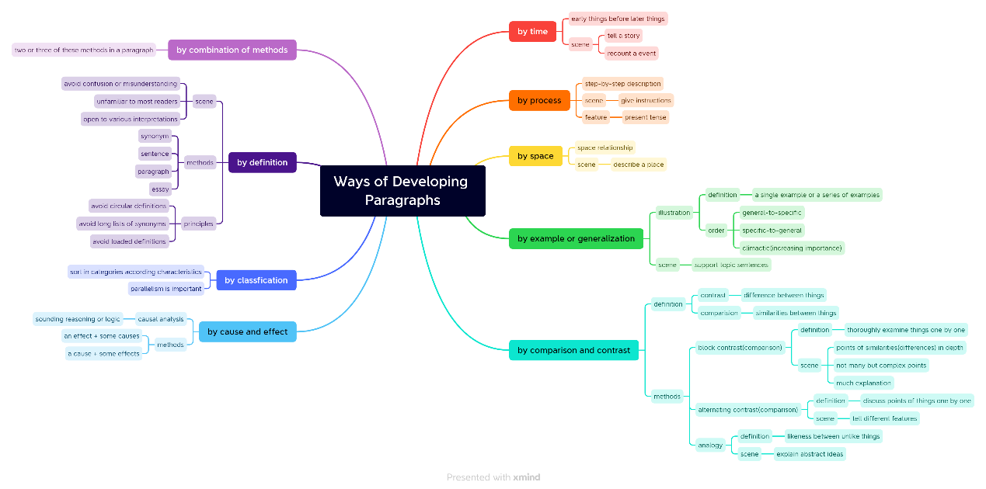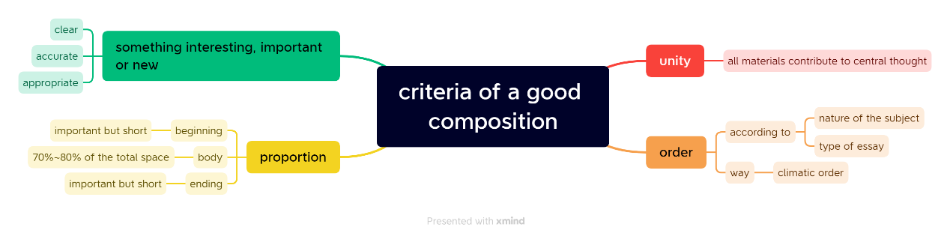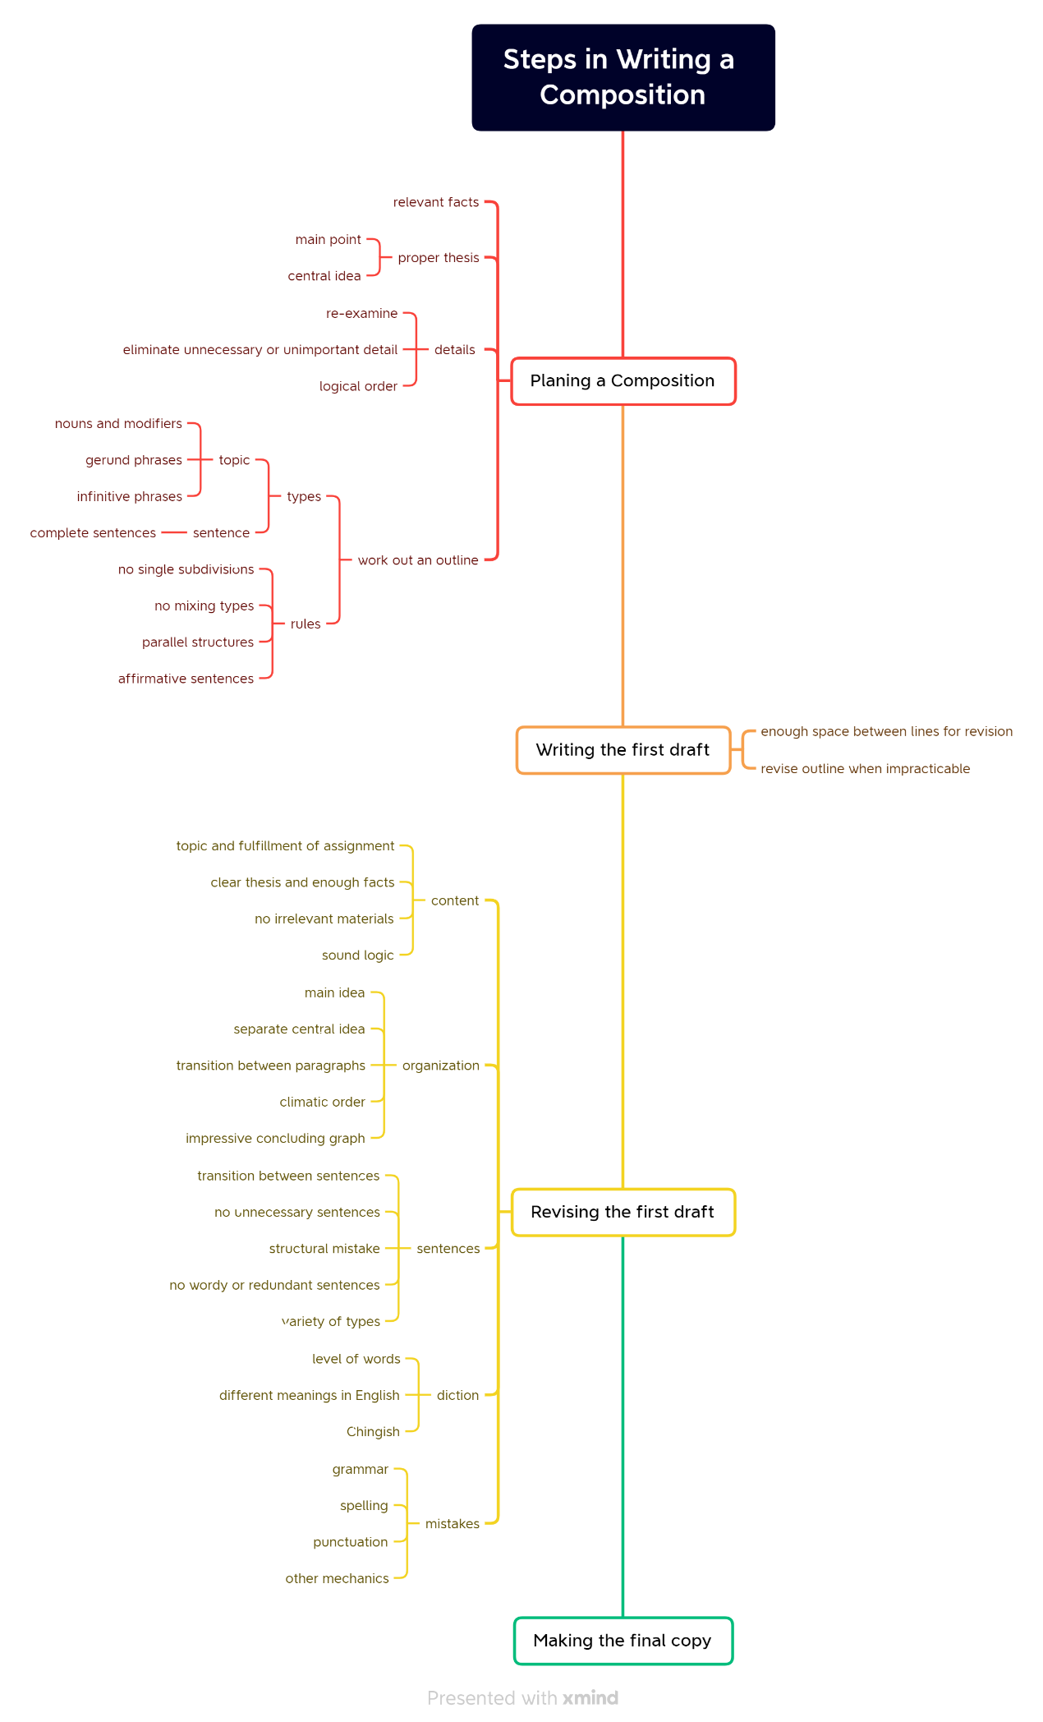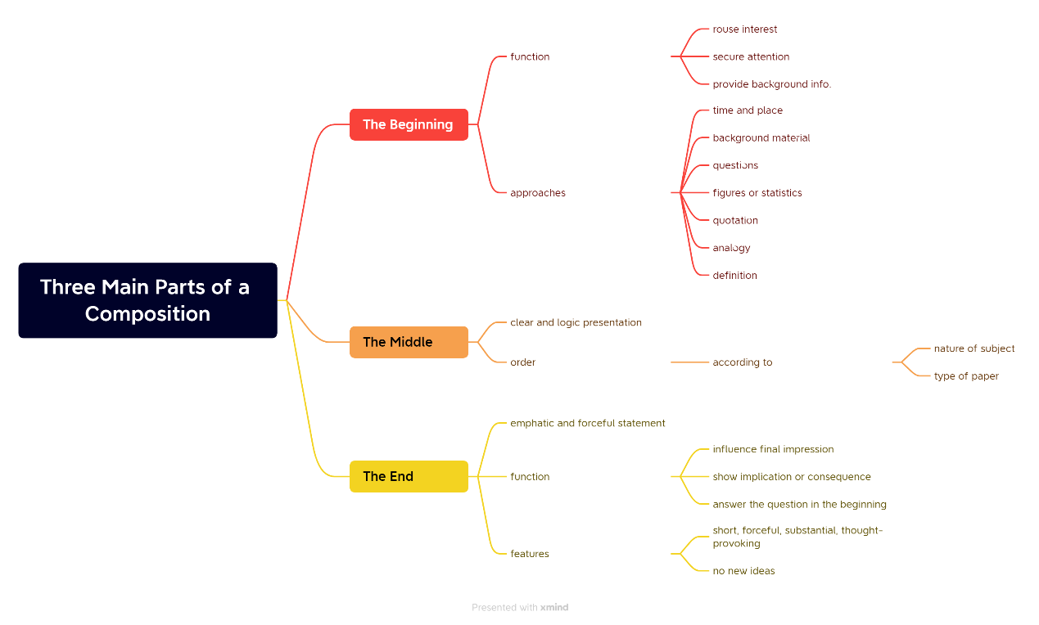*
2. *Learning outcome*
   1. *When developing paragraphs, we should arrange materials in a reasonable order according the situation and requirements.*
   2. *The requirements towards composition have similarities with that towards paragraph. The unity and order should be seriously considered.*
   3. *Writing composition should strictly follow the steps. Outline writing, revising and copying shouldn’t be neglected or skipped, for they contribute to the expression of your ideas.*
   4. *When organization composition, we should pay attention to the organization of three parts: the beginning, the middle and the end. The beginning and the end should be brief and clear, and the middle part should be arranged in a reasonable order.*